Tenda MW5-How to check connection type of the devices?

Step 1: Open Tenda App, tap “Connected devices”.

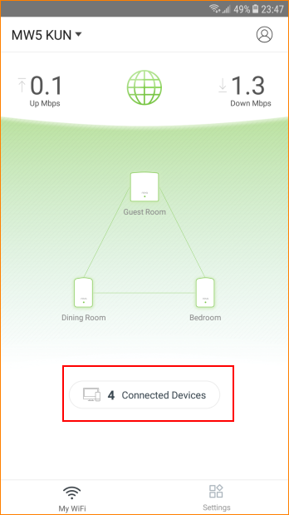

Step 2: Connection type is showed below the host name of the device.

